## BUS256 Marketing Analytics Spring 2017

### Capital One (revisited) Competitive Analysis

**Introduction:**  Working alone or in a group of up to three people, submit a brief report in response to the questions posed here. When we discussed the Capital One case at the start of the course, we noted that Richard Fairbank had truly changed the consumer credit card industry. According to S&P CapitalIQ, thirty years since it was founded, Capital One Financial (COF) now has the second-largest market share in the industry:

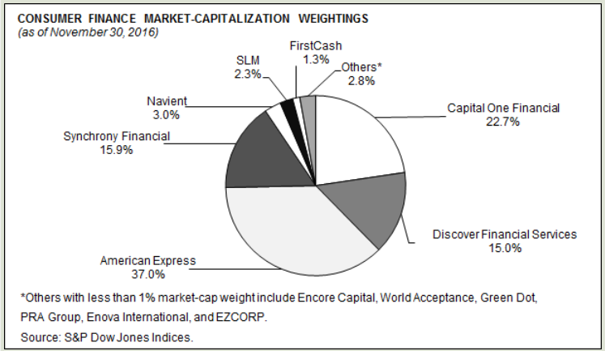

**Objectives**:

* Use some of the web-scraping and visualization techniques covered in Miller Chapter 12 to analyze one industry
* Compare closing prices for the leading firms in the industry
* Investigate relationships (if any) between COF share prices and economic indicators of your choice.
* Pull together knowledge from other IBS courses as it relates to this course

**Summary**: Miller’s Chapter 12 demonstrates how we can scrape the web for equity prices as well as various macroeconomic metrics, and can create time-series graphs of the data we gather. In this revisiting of Capital One, we will look at their relative position in the industry in reference to major competitors and the general economic environment.

**Tasks and Questions:** Note: Whenever you prepare a graph, include it within your paper (i.e. copy/paste from R)

1. (10 pts) Prepare a plot that shows COF share prices since Jan 1, 2000.
2. (20) Prepare a plot that compares share prices of COF to American Express, Discover Financial Services, and Synchrony Financial since Jan 1, 2000. Comment on the comparison.
3. (25) Choose one of the indicators that Miller demonstrates (e.g. consumer sentiment, unemployment, etc) and prepare an informative graph that shows the movement of that indicator over time in comparison to COF shares. Comment on the comparison that you see and what it might indicate for Capital One.
4. (25) In R, run a simple linear model (command “lm”) with COF prices as Y and your selected indicator from question 3 as X. Explain the model findings as they might be relevant to a marketing manager at COF.
5. *(20) Challenge*: Obtain data on COF quarterly Total Revenue for the past 12 quarters. (You might scrape this, or may have to obtain it in more conventional ways). Do some research to discover how to prepare a forecast for the next quarter using a simple linear trend analysis. Report on your method and explain your forecast.
6. *Extra Credit (10 pts)*: Miller shows us several sources of industry and economy-wide data. See if you can scrape indeed.com for any jobs at Capital One in Boston, and report back on one of them. You must do the searching in R!

There is no prescribed length for your paper. Just respond to all questions.

At the end of the paper, copy & paste all of your R code.